

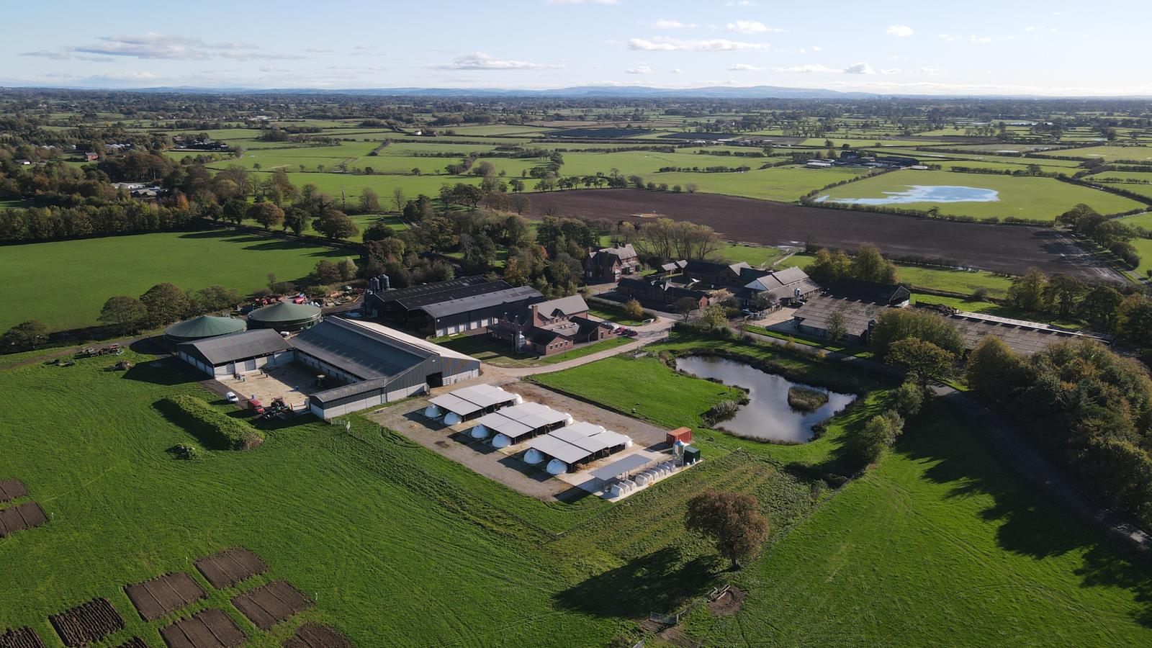

# Director of Farm

# Operations and Innovation

# Application Pack

# TABLE OF CONTENTS

1. Welcome letter from the Chief Executive & Principal Page 2

1. About Myerscough College and Farming Operations Page 3

1. Job Description Page 7

1. Employee Specification Page 12

1. Useful Web Links Page 15
2. How to Apply Page 15

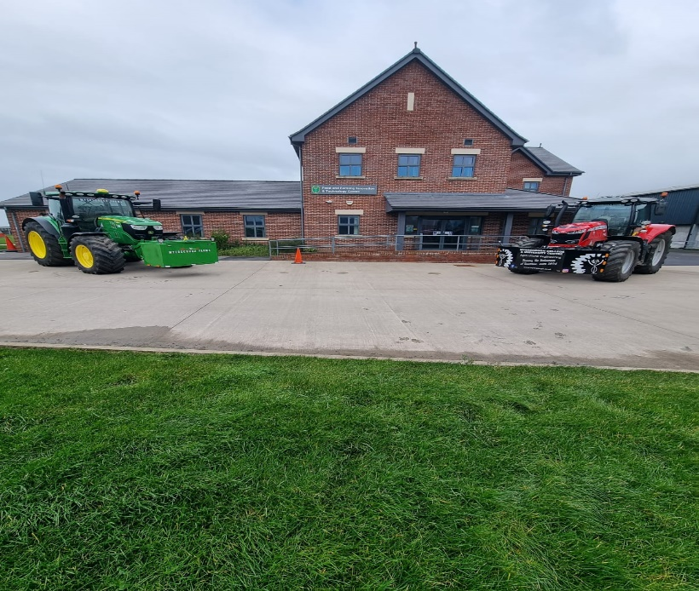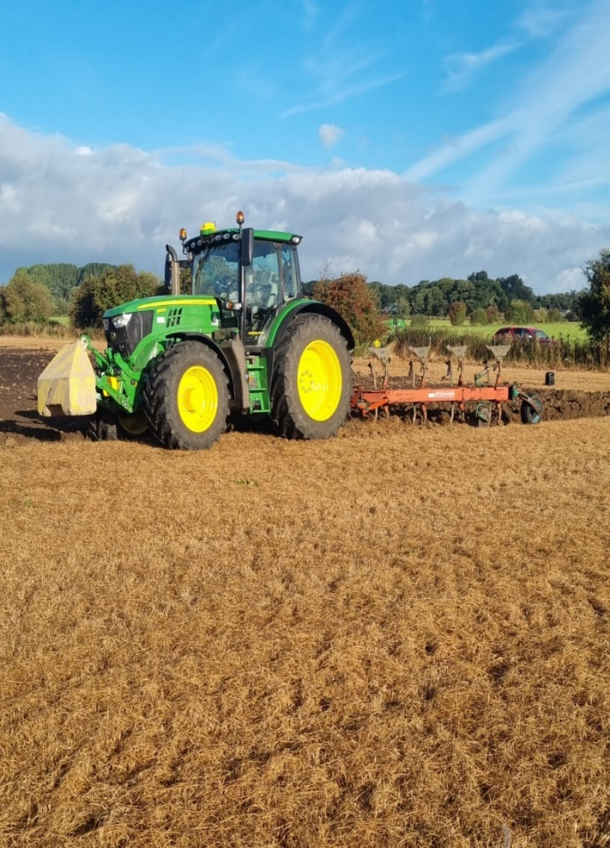

# WELCOME LETTER FROM THE CHIEF EXECUTIVE & PRINCIPAL

Dear Candidate

Thank you for your interest in the role of Director of farming Innovations and Operations at Myerscough College and University Centre (hereafter, called Myerscough College) in Lancashire and a very warm welcome to one of the leading specialist land based, science, engineering, and sports colleges in the country. This role will provide a strong, ambitious and passionate leader with the opportunity to make a significant contribution to the agricultural and educational landscape of Lancashire and the wider North West of England.

Myerscough College has an annual turnover of c£34m and is rated by the Education Skills Funding Agency (ESFA) as “outstanding” for financial health. The person appointed will be a member of the Senior Leadership Team and will report to the Deputy Principal Resources. The Director will be responsible for all aspects of strategic decision making linked to the Colleges farming operations including farming practice, agricultural strategy, research on the farm, farm budgets and financial planning, and all staffing matters.

Working with our committed, knowledgeable, and enthusiastic Myerscough team in industry standard facilities alongside a wide range of regional and national partners, our mission is to inspire excellence. We pride ourselves in providing students with not only a first-class academic qualification but also the practical skills to meet the needs of industry and ensure their future employability. Delivering courses from entry to postgraduate level, alongside apprenticeships, Myerscough provides opportunities for academic progression, whilst strong industry links with over 1400 employers ensure that the courses are not only industry relevant but also provide the best opportunities to progress into employment.

The College is an inclusive, caring community, putting the needs of our students at the heart of all decision making and ensuring their safety and wellbeing is paramount. The College is judged by Ofsted as good for the quality of education and residential care of students and has a dedicated team providing student support and welfare, which ensures that each student is valued and able to gain confidence and achieve their full potential.

We believe that Myerscough is a special place to live, work and study and we are truly passionate about the future for Myerscough and the difference it can make to so many individuals. We are now seeking an inspirational, Director who is fully committed to building further on the current successes of the College ensuring an outstanding reputation for agricultural and farming practice, research and agricultural education, training, and knowledge transfer services to our stakeholders.

If you are interested in joining the Myerscough team and pursue your interest in this unique opportunity, then I look forward to receiving your application.

Alison Robinson

Chief Executive & Principal



# ABOUT MYERSCOUGH COLLEGE AND FARMING OPERATIONS

Myerscough College is a specialist land based, science, engineering and sports college based near Preston in Lancashire with centres in Liverpool, Blackburn, Manchester, Penrith and Warrington. It delivers courses from entry level to postgraduate within these specialist areas, supporting not only the local but also the regional, national, and increasing international skills need. It was originally established as Lancashire County agricultural training centre in 1894, making it not only one of the largest but also one of the oldest specialist colleges in the country.

The College offers agricultural courses at Further Education (FE 14-16, 16-18, adult education and apprenticeships) and Higher Education (HE) and is considered a leading national educational institution for Agriculture. Agricultural provision is taught mainly from our College farms at our Bilsborrow site, near Preston, Lancashire with some theory teaching delivered across a range of centres in Cumbria.

Extensive training and educational use are made of the 300ha College Farm by many sections of the College, including agriculture, agriculture apprenticeships, agricultural engineering, game-keeping, countryside, arboriculture, foundation learning, equine, animal welfare and management, ecology, Veterinary Nursing, and research. The range of commercial livestock and crop enterprises – currently 200 dairy cows, beef from the dairy unit, a suckler herd, 1000 lowland sheep flock and combinable crops grown as forage – are all important both educationally and for research.

**Farm Strategic Plan**

The farms strategic plan identifies the following aims and objectives –

**Aims**

* Provide a centre of training excellence in agriculture and related subjects for students studying at both FE and HE.
* Provide employers with FE and HE graduates of the highest calibre in terms of the technical and professional skills required on modern progressive farms and related businesses.
* Demonstrate best practice in modern, sustainable farm and estate management to land-based students, businesses, and organisations in the North-West.
* Promote agriculture at Myerscough within the agricultural sector and to the wider community including schools, businesses, and the public.
* Develop novel and new technologies via research to support the agriculture industries and underpin the curriculum.
* Enhance accessibility to the farm for all providing a shop window to promote the positive aspects of modern agriculture and sustainable land management practices.
* Operate a financially viable commercial farming operation which meets the needs of curriculum and industry.

**Objectives**

* Continually improve and develop the farm to reflect modern farming and land management practice to meet the needs of the agriculture and related subjects’ curriculum. Through developments demonstrate modern farming practices with emphasis on developing precision farming principles that reflect current or very recent farming technology developments.
* Ensure effective communication between teaching staff and farm staff to facilitate the free flow of information both ways. Ensure the provision and use of readily accessible, up to date physical and financial farm management data that is typically found on progressive farms, demonstrating cutting edge, sustainable farming practice. Develop farm staff in understanding teaching and learning skills to enhance student experience whilst gaining work skills on the farm.
* Pursue and develop suitable research opportunities on the farm as they arise with industry and other Higher Education Institutions. Promote knowledge transfer of relevant and appropriate research and activities to agri-businesses to assist with business development.
* Engage with media and key industry representatives at both regional and national level to promote the outstanding features of all aspects of agriculture at Myerscough.
* Investigate and evaluate new opportunities that may arise for the farm to remain viable, representative of farming in the region and meet the needs of education.

**Investment in College Farming Innovations and Operations**

In order to support the achievement of these overarching aims and objectives the College recognised an essential need to invest in its farm facilities and in new technology to support curriculum delivery and business development.

In 2017 the College opened a new Food and Farming Innovation and Technology Centre to support the adoption of precision farming techniques particularly within the livestock and grassland sectors. Whilst the Centre itself provides training, conference, and laboratory facilities the project also supported the investment in new facilities and technology for the farm itself. This included –

* 100GB data connection to all farm sites.
* Wi-fi coverage of all farm sites.
* New livestock building with associated silos, feed and slurry storage including –
  + Grosafe feeder technology
  + Automatic ventilation system
  + Animal behaviour CCTV monitoring
  + Purpose built handing system with hydraulic crush, EID reading and weigh recording.
* Milking parlour upgrade with Afi Milk technology.
* Hanskamp out of parlour feeders allowing 2 hard feeds and a liquid feed to be fed at all units.
* Alterations to dairy unit to improve cow comfort and welfare.
* Precision fertiliser spreader.

This investment in technology has allowed significant improvements in farm performance to be achieved. It has also driven changes within curriculum delivery that has led to the use of the technology being embedded within teaching. This has been positively received by students and has helped drive increased student recruitment.

The investment in technology and resources made possible by the original FFIT project has also created significant knowledge transfer opportunities for farmers and to date over several thousand farming businesses have visited the centre to gain an understanding of how the adoption of technology could assist their own business.

In 2019 the College secured further funding to invest in new calf rearing facilities, which again included the adoption of automated feeding technology. In the spring of 2020, the College opened a new calf rearing facility using Holm and Laue veranda and igloo system in conjunction with automated feeding stations with weighing capability. Again, this investment has brought about labour savings and enterprise performance improvements whilst at the same time creating further opportunities to deliver knowledge transfer activities for farm businesses.

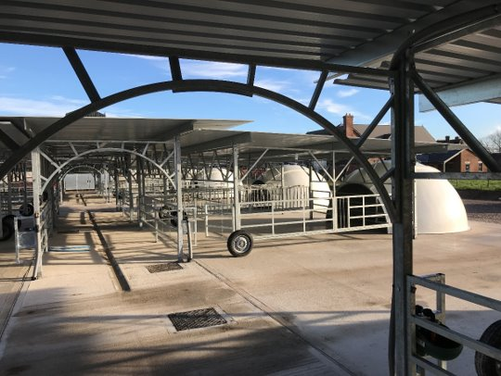

Based on this continued investment in technology the College dairy unit was selected as an AHDB Strategic Dairy Farm in the autumn of 2020 and has since hosted a series of events for levy payers.

In addition, the College has led a £9m pilot of the Strategic Development Fund across the Lancashire Colleges on working towards the net zero carbon agenda. This has included Myerscough College’s ‘Ag Net-Zero Challenge’ which has involved working with local farmers and growers to address the question of “What about carbon?”. This challenge has attempted to demystify carbon management for individual businesses by providing solutions, making efficiencies, and improving productivity while reducing carbon footprint. The Myerscough College Ag Net Zero Challenge has completed ten carbon audits across various farm types in Lancashire. These audits demonstrate where the carbon emissions are occurring and the necessary mitigation measures to reduce them. The College has also delivered Carbon Farm Roadshows and presented the results of the audits to groups of Lancashire farmers. To support the project a range of innovative capital equipment has been purchased to enable teaching and learning at Myerscough College to be demonstrated by using the latest technology including the latest tractors, harvest lab, umbilical, direct drill, and self-propelled feeder wagon with cutter head technology.

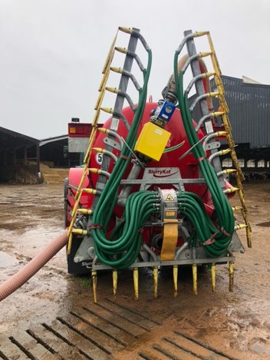 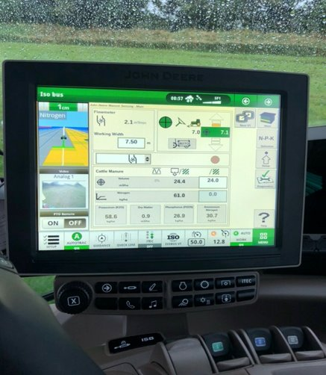

To continue this direction of travel the College has allocated funding and made a further grant application to support the installation of robotic milking into the existing dairy unit. Design work has been completed and tenders received in readiness for confirmation of the grant funding. The installation is scheduled to be complete by November 2022 and should again allow the farm to continue to demonstrate the adoption of precision farming technology and further enhance the farms capability to support modern training for students and allow other farm businesses to understand how the adoption of technology can assist their own business.

The College farm work in conjunction with researchers at both University Centre Myerscough and other universities to carry out research towards Masters and PhDs and to support funded research. The College is currently undertaking work around agricultural data technology with specific projects around milk parlour automation data and arable land treatment. Examples of PhD research currently being supported include research on the responsible use of medicines in dairy cows and Food Security: Sustainability of Lazybed Re-cultivation.

# JOB DESCRIPTION

|  |  |
| --- | --- |
| **JOB TITLE** | **AREA OF WORK** |
| Director of Farm Operations and Innovation | Farms / Estates |
| **SALARY** | **BENEFITS** |
| £45,334 to £60,000 per annum relating to qualifications and experience | Local Government Pension Scheme  38 days annual leave, plus Bank Holidays to include up to 5 days to be taken between Christmas and New Year at direction of the Principal  A College house to live in for the duration of the contract |
| **LINE MANAGER(S)** | **LINE MANAGER FOR** |
| Deputy Principal Resources | Farm Personnel |
| **KEY TASKS AND RESPONSIBILITIES** | |
| To provide visionary and dynamic leadership, which drives the strategic direction, management of the College’s farming operations, and farm based technology led innovation developments. | |
| Liaison and communication with land based industries to promote farm operations and innovations thereby developing partnerships and links to support activities. | |
| Determining the overall farm management strategy and plan for the College farms. | |
| Oversee the Implementation of farm management plan and production plans for the College farms. | |
| Champion the provision of high quality teaching, research and scholarly activities throughout the College Farms. | |
| Direct liaison with curriculum and research teams to ensure effective and efficient use of all farm resources. | |
| Overall management responsibility for all farm personnel. | |
| To ensure that communication systems and practices support effective management arrangements and promote good relations with staff and students. | |
| Contribute to the successful delivery of the College’s overall Strategic Plan. | |

|  |
| --- |
| **DUTIES** |
| **Strategic Management**  Influence and guide the strategic direction and development of the farm and Food, Farming, Innovation and Technology (FFIT) project in order to achieve the following objectives: –   * To create a centre of excellence and innovation to lead the development of precision farming within livestock and grassland sectors. * To provide an inspirational learning environment for students and encourage technologically minded individuals to enter the industry where there is a significant skills shortage. * To encourage both high level and applied research and its application to the farm, bringing together academics within the industry, technologists and farmers to ensure the roll out of research and innovation to increase productivity. * Assist and contribute to the operating plan for the FFIT Centre and undertake activities and provide information to support the delivery of the FFIT project targets. * Promote and contribute to public and community relations by facilitating events and activities, which promote the use of the farms and its facilities whilst developing a greater understanding of farming and rural businesses with individuals, groups, students and school children.   **Farm Management**  To be responsible for:   * Overseeing the day to day management of the College farms and implementation of the overall approved farm strategy. * Providing a centre of training excellence in agriculture and related subjects for students studying at both FE and HE. * Providing employers with FE and HE graduates of the highest calibre in terms of the technical and professional skills required on modern, progressive farms and related businesses. * Demonstrating best practice in modern, sustainable farm and estate management to land-based students, businesses and organisations in the North West. |
| * Promoting agriculture at Myerscough within the agricultural sector and also to the wider community including schools, colleges, universities, businesses and the general public. |

|  |
| --- |
|  |
| * Promoting the development of novel and new technologies via research to support the agriculture industries and underpin the curriculum. |
| * Enhancing accessibility to the farm for all providing a shop window to promote the positive aspects of modern agriculture and sustainable land management practices. |
| * The efficient organisation and effective utilisation of the College farm staff and particularly the monitoring of staff usage. |
| * The physical and financial monitoring to ensure performance indicators are met. Performance indicators would be reviewed annually and agreed. |
| * The preparation of all budgets including long term capital expenditure. |
| * In conjunction with the Farm Secretary ensure the maintenance and completion of all necessary records required not only for the efficient management of the business but also for academic purposes. |
| * The determination and control of all marketing plans for all products sold from the College farms, developing new business proposals, as necessary in order to maximise appropriate business opportunities. |
| * Managing the Farm Secretary to ensure the maintenance of a farm information room and to update both staff and students, as required from time to time. |
| * The provision of suitable academic practical facilities including the requirements of research activity. |
| * Ensuring the proper care, maintenance and servicing of all vehicles, machines and equipment under his / her control. |
| * Leading and managing the farm workforce in line with College policies and procedures. |
| * Ensure the security and safety of all livestock, equipment and goods on the College farms. |
| * Ensuring that animal welfare standards are of a high standard, are monitored and targets are achieved. |
| * Ensuring that full compliance with all legislative and standards is achieved at all times. |
|  |

|  |
| --- |
| **ROLE SPECIFIC KEY DUTIES** |
| **Equality, Diversity and Inclusion - FREDIE**   * Lead, monitor and report on strategies within the area Farm Operations and Innovation to promote and advance fairness, respect, equality, diversity, inclusion and engagement. * To understand and remove any barriers and address any gaps in participation and performance. |
| **Health and Safety**   * Lead the Farms team activities to ensure full compliance with agreed safety, quality and environmental standards and expectations and promote best practice, wherever possible. |
| **OTHER DUTIES** |
| * To be available to attend in emergencies at nights and weekends for matters relating to farm security, fire and damage, infrastructure / utility failures and essential health and safety concerns. * To assist with the planning and implementation of events such as farming and related events, open days, employer showcasing events, research conferences, careers events, graduations and other special events. |
| **GENERAL DUTIES** |
| * Role model and promote the College values: * Respect for yourself, each other and the environment * Welcoming, honest and inclusive * Happy, safe and supportive culture * Inspiring learners and staff to be the best they can be * Positive and innovative. |
| * Manage, monitor and track the Staff Performance Enhancement Reviews process in line with College needs. Agree objectives with the Line Manager and ensure they are achieved. |
| * Be responsible for promoting and safeguarding the welfare of children, young people and vulnerable adults at all times in line with the College’s own Safeguarding Policy and practices. |
| * Be committed to the advancement of equality of opportunity in both service delivery and employment to include participation in the Leaders in Diversity, Disability Confident Mindful Employer Schemes. The College’s mission and strategic objectives directly support this aim. Ensure all employees support this aim and its implementation pro-actively. |
| * Be thoroughly aware of College Health and Safety policies and procedures, and attend any mandatory health and safety training appropriate to their role and ensure that employees within their responsibility are also made aware of these policies and procedures and any mandatory training relevant to their role.  They must also seek to ensure appropriate implementation of such policies and procedures across all areas of their responsibility. |
| * Ensure all accidents and near misses are recorded and reported following College procedures. |
| * Lead the promotion of College sustainability policies and strategies by personal commitment and lead by example. |
| * Adhere to the Data Protection Act 1998 and the General Data Protection Regulations 25 May 2018 and must be thoroughly aware of the College Data Protection Policy and Procedure and ensure that employees within his/her responsibility are also.  He/she must also seek to ensure appropriate implementation of such policies. |
| * Complete any other duties that may reasonably be required by Line Management and the Principal. |

**Location of work**

You may be required to work at or from any building, location or premises of Myerscough College, and any other establishment where Myerscough College conducts its business.

**Variation to this Job Description**

This is a description of the job as it is at present, and is current at the date of issue.  The job description will be renewed and updated as necessary to ensure that appropriate revisions are incorporated, and that it relates to the job to be performed.  This process is conducted jointly with your Line Manager.  You are expected to participate fully in the review and, following discussion, to update your job description as is considered necessary or desirable.  It is our aim to reach agreement on reasonable changes.  However, if such agreement is not forthcoming, Management reserves the right to insist on changes after consultation with you.

# EMPLOYEE SPECIFICATION

(A) Assessed via Application form ( I ) Assessed via Interview

(P) Assessed via Presentation in interview (T) Assessed via Test

|  |  |
| --- | --- |
| **ESSENTIAL CRITERIA:** | **DESIRABLE CRITERIA:** |
| ***Personal Attributes*** | |
| Presentable and professional appearance (I)  Ability to work as part of a team (A/I)  Ability to work to quality standards (A/I)  Good command of the English language (A/I)  Appropriate level of physical and mental fitness (A/P/I) Adaptable and able to work flexibly, within a team or on own initiative (A/I) |  |
| ***Attainments*** | |
| Honours Degree in Agriculture or directly relevant discipline (A)  Proven farm management experience (A/I)  Experience of personnel management including recruitment, supervision and evaluation (A/I) | Postgraduate qualification in agriculture or directly relevant discipline (A)  Financial or business qualification (A)  Research experience (A/I)  Extensive and demonstrable industry links and connections (A/I)  Practical farming experience (A/I) |
| ***General Intelligence*** | |
| Outstanding ability to lead and manage (A/I/P/T)  The capacity to communicate highly effectively both verbally and in the written word at all levels and via electronic methods/media (A/I/P/T)  IT literate and able to use a variety of IT programmes. (A/I)  Confident interpreting and analysing data to write evaluative reports (A/I/P/T)l |  |
| ***Special Aptitudes*** | |
| Outstanding leadership / communication skills and the ability to motivate a team (A/I/P)  Clear evidence of the ability to build strong partnerships with external stakeholders (A/I) | Presentation skills (I) |
| ***Interests*** | |
| High levels of interest in the work and achievement of students and staff (A/I/P/T)  High levels of interest in promoting best practice in agriculture and animal welfare standards (A/I/P)  Full commitment to ensuring a high quality student and curriculum experience (A/I/P/T)  A good understanding of the uses of technology in modern farming practice (A/I/P) | High levels of interest and good links to the countryside and rural communities (A/I) |

|  |  |
| --- | --- |
| ***Disposition*** | |
| Excellent interpersonal skills (I)  Excellent communication skills (I)  Approachable (I)  Person centred approach (I)  A leader who is hard working and capable of developing the performance of others (A/I)  Able to motivate and inspire staff and students to high achievements (A/I/P)  Innovative problem solver with a challenging & commercial outlook (A/I/P) |  |
| ***General*** | |
| An understanding of “safeguarding” and its importance within the College * (A/I)  An understanding of health and safety requirements of a working and farming environment (A/I)  An understanding of equal opportunities issues and willing to positively promote fairness, respect, equality, diversity, inclusion and engagement within an educational and farming context (A/I) |  |
| ***Circumstances*** | |
| Willing to apply for Disclosure & Barring Service clearance at Enhanced level (important – further information below) (A/I)  Ability and willingness to work flexibly (I)  Current driving licence (A) |  |

*Interviews will explore issues relating to safeguarding and promoting the welfare of children, including motivation to work with and ability to form and maintain appropriate relationships and personal boundaries with children and young people together with emotional resilience in working with challenging behaviours and attitudes to use of authority and maintaining discipline

# EMPLOYEE SPECIFICATON

|  |  |
| --- | --- |
| **JOB TITLE** | **AREA OF WORK** |
| Director of Farm Operations and Innovation | Farms / Estates |
| **SALARY** | HOURS OF WORK |
| £45,334 to £60,000 per annum relating to qualifications and experience | 37 hours per week |
| ANNUAL LEAVE ENTITLEMENT | PENSION |
| 38 days holiday, plus Bank Holidays to include up to 5 days to be taken between Christmas and New Year at direction of the Principal | Local Government Pension Scheme  Up to £15,000 pa 5.5% Employee  £15,001 to £23,600 pa 5.8% Employee  £23,601 to £38,300 pa 6.5% Employee  £38,301 to £48,500 pa 6.8% Employee  £48,501 to £67,900 pa 8.5% Employee  £67,901 to £96,200 pa 9.9% Employee  £96,201 to £113,400 pa 10.5% Employee  £113,401 to £170,100 pa 11.4% Employee  £170,101 or more pa 12.5% Employee  17.4% Employer  You will automatically become a member of the LGPS |
| PROBATIONARY PERIOD | DRESS CODE |
| A probationary period of nine months applies to new entrants to the College | All post holders are expected to be of a professional and presentable appearance |
| REFERENCES / MEDICAL CLEARANCE / DISCLOSURE | |
| The appointment is subject to the receipt of satisfactory references, medical clearance and Disclosure & Barring Service check/ISA (if applicable).  Occupational Sick pay is not paid during the first four months of service and thereafter is subject to the College’s Sick Pay Scheme  **Please note that all new employees of the College will be required to pay for their DBS check (at present £44.00 for an enhanced level check).**  **Should your application be successful the College will process and pay for the DBS check on the employees behalf. The fee will then be deducted from the employee’s first salary.**  **Please see overleaf regarding DBS Update Service.** | |
| **COLLEGE VALUES** | |
| Promote the College values:   * Respect for yourself, each other and the environment * Welcoming, honest and inclusive * Happy, safe and supportive culture * Inspiring learners and staff to be the best they can be * Positive and innovative   ***Employees are expected to take responsibility for managing their own health, safety and wellbeing*.** | |

# USEFUL WEB LINKS

1. College Website [www.myerscough.ac.uk](http://www.myerscough.ac.uk/)
2. LANDEX [www.landex.ac.uk](http://www.landex.ac.uk/)
3. Skills Accelerator Project in Agriculture [Ag Net-Zero Challenge – The Myerscough College Ag Net Zero Challenge](https://agnet-zerochallenge.com/)

# HOW TO APPLY

Please complete a full Myerscough College application form available from Myerscough College website under Vacancies. College website as detailed above.

**Recruitment Timetable:**

|  |  |
| --- | --- |
| Closing Date for Applications | Thursday 7th July 2022 at 12 noon |
| Assessment Centre | Friday 15th July 2022 |