The Library (which includes the HE Centre) at Myerscough puts care and service to our students as its highest priority. There is the main library on the Preston campus and smaller scale libraries at our other centres - Croxteth and Witton. Currently of course it is mainly providing electronic books and journals to help students who are studying at home and it has its own pages for each subject area on the College VLE (Canvas). The Library also provides easy to follow guides for each subject area to help students find their way around e-resources and the main library with all its specialist book collections. We are intending to still make the physical library resources available next academic year and to provide an excellent, safe study space on campus within the new guidelines. We also have a very friendly team of staff who are always happy to help – either in person or on-line.
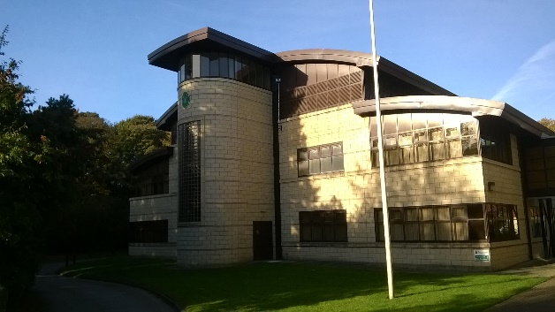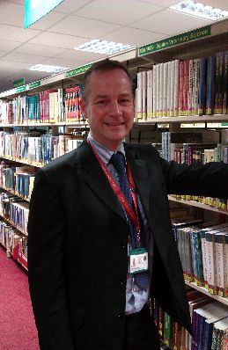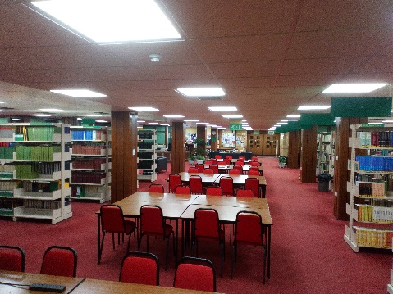
Library building – Preston campus Jon – our Head Librarian Main reading area
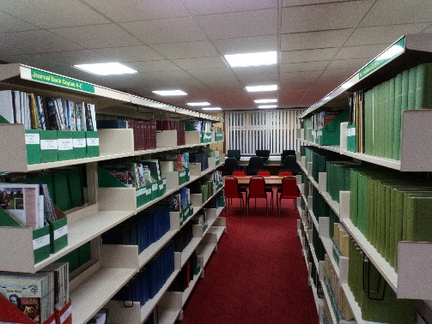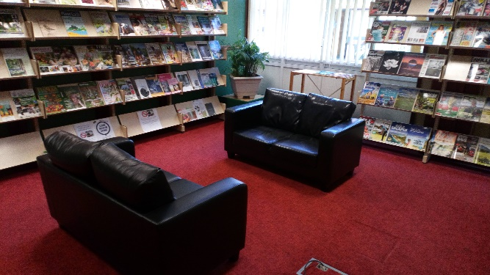
Academic Journals Magazines area
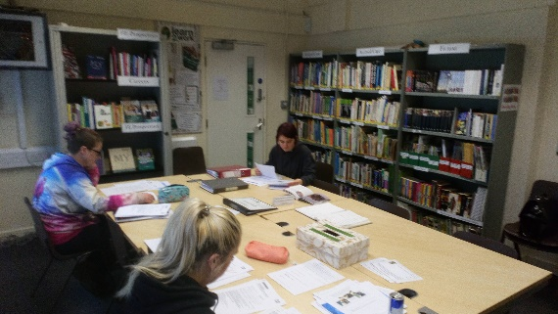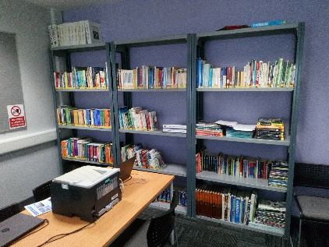
Branch library at Witton Centre One of the classroom collections at Croxeth

