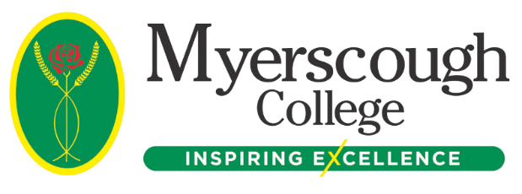

It is nearly time to enrol at Myerscough College!

Here at Myerscough College, we are looking forward to welcoming you on your first day at the start of the autumn term in September, a big step towards a successful future.
In the meantime, please follow the checklists below and complete the steps needed so that you are all set for GCSE Results Day on Thursday 25th August!

Checklists for Enrolment

Checklist 1: Enrolment Preparation and Information

Checklist 2: Instructions for Applicants from GCSE Results Day and onwards (even if you have an Unconditional Offer)

By following the steps in both guides, you will ensure that you are 100% prepared to enrol and start with us in September. These guides are available in a PDF format upon request. You can access the full Admissions Guide here.

Your First Day

Your first day at Myerscough will depend on the final confirmation of your course and which centre you are attending. More information can be found on the Start Date section on the Admissions Guide (please note, some areas are still making final preparations for start dates so, if there is currently no information, keep checking back). We will also provide more information with your confirmation email on or after GCSE results day. In most cases, your start date will take place on the week commencing 5th September 2022.

Quick Tips

- If you are expecting results on 25 August 2022, remember to upload them no matter what grades you achieve. If they aren’t what you were expecting, then they will be referred to our specialist teams to either make an alternative offer of a relevant course or to provide a plan to allow you to enrol at Myerscough in the future*.
- Your timetable will be confirmed shortly after your enrolment and will be available to view on My Student Portal.
- Shortly after you receive your course confirmation email, we will send a further email with details on how to prepare for your first day.
- If you already have an Unconditional Offer or are not awaiting any results, following the steps in the checklists will allow you to enrol as soon as possible.
- If you are staying in our residential accommodation (Preston students only), you will shortly receive and invitation to arrive on the Sunday before your course starts.
- If you studied as an FE student with us last year (not including 14-16 applicants), then we will enrol you automatically over the summer based on your results. Check the Admissions Guide for more information.

* Please remember that if you don’t pass Maths and English at Grade 4 or above and you are aged under 19, you will be required to enrol on the relevant subject, alongside your main course, until you achieve a suitable grade, as set out in the Government Guidance.

Key Contacts

Bursary Information:

You can find detailed information on our Finance webpage.
Email: bursary@myerscough.ac.uk or Telephone: 01995 642398

Bus Pass and Bus Times Information:

You can find detailed information on our Transport webpage.
Email: transport@myerscough.ac.uk or Telephone: 01995 642138

Work Placement Queries:

Visit our Work Placement webpage.
Email: workplacement@myerscough.ac.uk

Residential Accommodation (Preston only):

Residential accommodation can be applied for via My Student Portal.
Email: reshelp@myerscough.ac.uk

See you soon!

If you have completed every action in the checklists, you will be up to date with everything that you need to do at this point. Don’t forget you can also access the My Future pages (login details can be found in your offer email) to access course information and get a sneak peek at what and how you will be studying with us in September.

With a high number of our learners going into further study or finding employment within six months of completing their course, by choosing Myerscough, you will be giving yourself an exceptional opportunity to succeed on your course and in your chosen career.

Best wishes

The Myerscough Admissions Team

