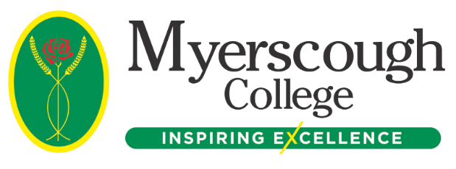

Dear Parent/Guardian
It is nearly time for our applicants to enrol at Myerscough College.

Here at Myerscough College, we are looking forward to welcoming our students at the start of term in September. In the meantime, there are some actions our applicants have been advised to complete before GCSE Results Day on Thursday 25th August.

Checklists For Enrolment

Checklist 1: Enrolment Preparation and Information

Checklist 2: Instructions for Applicants from GCSE Results Day and onwards (even if you have an Unconditional Offer)

By following the steps in both guides, applicants will be 100% prepared to enrol and start with us in September. These guides are available in a PDF format upon request. You can access the full Admissions Guide here.

First Day

The student’s first day at Myerscough will depend on the final confirmed course and which centre they are attending. More information can be found on the Start Date section on the Admissions Guide (please note, some areas are still making final preparations for start dates so, if there is currently no information available, keep checking back).

Quick Tips

- If applicants are expecting results on the 25th August, remember to upload them as per the guide, no matter what grades they achieve. If they aren’t what they were expecting, then they will be referred to our specialist teams to either, make an alternative offer of a relevant course or to provide a plan to allow them to enrol at Myerscough in the future.
- Shortly after they receive a course confirmation email (after submitting their results), we will send a further email with details on how to prepare for their first day.
- If they already have their results or have an unconditional offer, then following the steps in the checklist will ensure enrolment can take place swiftly.
- If staying in our residential accommodation (Preston students only), they will shortly receive and invitation to arrive on the Sunday before your course starts.
- If the applicant studied as an FE student with us last year (not including 14-16 applicants), check the Admissions Guide for more information about returning applicants.

Key Contacts

Bursary Information:

You can find detailed information on our Finance webpage.
Email: bursary@myerscough.ac.uk or Telephone: 01995 642398

Bus Pass and Bus Times Information:

You can find detailed information on our Transport webpage.
Email: transport@myerscough.ac.uk or Telephone: 01995 642138

Work Placement Queries:

Visit our Work Placement webpage.
Email: workplacement@myerscough.ac.uk

Residential Accommodation (Preston only):

Residential accommodation can be applied for via My Student Portal.
Email: reshelp@myerscough.ac.uk

All Set!

Once every action in the checklists has been completed, then applicants will be up to date with everything that they need to do at this point.

With a high number of our learners going into further study or finding employment within six months of completing their course, by choosing Myerscough, students will be giving themselves an exceptional opportunity to succeed on their course and in their chosen career.

Best wishes

The Myerscough Admissions Team

